Assignment 2

Create a Database name entri_assignment

##### Create a Table with name departments

##### Department_id (pk) Department_name Location_id

##### Create a Table with name employees

##### Employee_id (pk) ,first_name,last_name ,email,phone_number,hire_date,

##### job_id, salary, commission_pct, manager_id, department_id (fk reference

## Insert into Departments table

INSERT INTO departments VALUES ( 170 , 'Payroll' , 1700);

##### ## Insert into Employees table

##### ; INSERT INTO employees VALUES (101, 'Neena' , 'Kochhar' , 'NKOCHHAR' , '515.123.4568' , '1989-11-21' , 'AD_VP' , 17000 , NULL , 100 , 20);

##### INSERT INTO employees VALUES (102 , 'Lex' , 'De Haan' , 'LDEHAAN' , '515.123.4569' , '1993-09-12' , 'AD_VP' , 17000 , NULL , 100 , 30);

##### INSERT INTO employees VALUES (104 , 'Bruce' , 'Ernst' , 'BERNST' , '590.423.4568' , '1991-05-21', 'IT_PROG' , 6000 , NULL , 103 , 60);

##### INSERT INTO employees VALUES (105 , 'David' , 'Austin' , 'DAUSTIN' , '590.423.4569' , '1997-06-25', 'IT_PROG' , 4800 , NULL , 103 , 60);

##### INSERT INTO employees VALUES (106 , 'Valli' , 'Pataballa' , 'VPATABAL' , '590.423.4560' , '1998-02-05', 'IT_PROG' , 4800 , NULL , 103 , 40);

##### INSERT INTO employees VALUES (107 , 'Diana' , 'Lorentz' , 'DLORENTZ' , '590.423.5567' , '1999-02-09', 'IT_PROG' , 4200 , NULL , 103 , 40);

##### INSERT INTO employees VALUES (108 , 'Nancy' , 'Greenberg' , 'NGREENBE' , '515.124.4569' , '1994-08-17', 'FI_MGR' , 12000 , NULL , 101 , 100);

##### INSERT INTO employees VALUES (109 , 'Daniel' , 'Faviet' , 'DFAVIET' , '515.124.4169' , '1994-08-12', 'FI_ACCOUNT' , 9000 , NULL , 108 , 170);

##### INSERT INTO employees VALUES (110 , 'John' , 'Chen' , 'JCHEN' , '515.124.4269' , '1997-04-09', 'FI_ACCOUNT' , 8200 , NULL , 108 , 170);

##### INSERT INTO employees VALUES (111 , 'Ismael' , 'Sciarra' , 'ISCIARRA' , '515.124.4369' , '1997-02-01', 'FI_ACCOUNT' , 7700 , NULL , 108 , 160);

##### INSERT INTO employees VALUES (112 , 'Jose Manuel' , 'Urman' , 'JMURMAN' , '515.124.4469' , '1998-06-03', 'FI_ACCOUNT' , 7800 , NULL 8 , 150);

##### INSERT INTO employees VALUES (114 , 'Den' , 'Raphaely' , 'DRAPHEAL' , '515.127.4561' , '1994-11-08', 'PU_MAN' , 11000 , NULL , 100 , 30);

##### INSERT INTO employees VALUES (115 , 'Alexander' , 'Khoo' , 'AKHOO' , '515.127.4562' , '1995-05-12', 'PU_CLERK' , 3100 , NULL , 114 , 80);

##### INSERT INTO employees VALUES (116 , 'Shelli' , 'Baida' , 'SBAIDA' , '515.127.4563' ,'1997-12-13', 'PU_CLERK' , 2900 , NULL , 114 , 70);

##### INSERT INTO employees VALUES (117 , 'Sigal' , 'Tobias' , 'STOBIAS' , '515.127.4564' , '1997-09-10', 'PU_CLERK' , 2800 , NULL , 114 , 30);

##### INSERT INTO employees VALUES (118 , 'Guy' , 'Himuro' , 'GHIMURO' , '515.127.4565' , '1998-01-02', 'PU_CLERK' , 2600 , NULL , 114 , 60);

##### INSERT INTO employees VALUES (119 , 'Karen' , 'Colmenares' , 'KCOLMENA' , '515.127.4566' , '1999-04-08', 'PU_CLERK' , 2500 , NULL , 114 , 130);

##### INSERT INTO employees VALUES (120 , 'Matthew' , 'Weiss' , 'MWEISS' , '650.123.1234' ,'1996-07-18', 'ST_MAN' , 8000 , NULL , 100 , 50);

##### INSERT INTO employees VALUES (122 , 'Payam' , 'Kaufling' , 'PKAUFLIN' , '650.123.3234' ,'1995-05-01', 'ST_MAN' , 7900 , NULL , 100 , 40);

##### INSERT INTO employees VALUES (123 , 'Shanta' , 'Vollman' , 'SVOLLMAN' , '650.123.4234' , '1997-10-12', 'ST_MAN' , 6500 , NULL , 100 , 50);

##### INSERT INTO employees VALUES (124, 'Kevin' , 'Mourgos' , 'KMOURGOS' , '650.123.5234' , '1999-11-12', 'ST_MAN' , 5800 , NULL , 100 , 80);

##### INSERT INTO employees VALUES (125, 'Julia' , 'Nayer' , 'JNAYER' , '650.124.1214' , '1997-07-02', 'ST_CLERK' , 3200 , NULL , 120 , 50);

##### INSERT INTO employees VALUES (126, 'Irene' , 'Mikkilineni' , 'IMIKKILI' , '650.124.1224' , '1998-11-12', 'ST_CLERK' , 2700 , NULL , 120 , 50);

##### INSERT INTO employees VALUES (127, 'James' , 'Landry' , 'JLANDRY' , '650.124.1334' , '1999-01-02' , 'ST_CLERK' , 2400 , NULL , 120 , 90);

##### INSERT INTO employees VALUES (128, 'Steven' , 'Markle' , 'SMARKLE' , '650.124.1434' , '2000-03-04' , 'ST_CLERK' , 2200 , NULL , 120 , 50);

##### INSERT INTO employees VALUES (130, 'Mozhe' , 'Atkinson' , 'MATKINSO' , '650.124.6234' , '1997-10-12' , 'ST_CLERK' , 2800 , NULL , 121 , 110);

### Solve SQL Exercises

1. Select employees first name, last name, job_id and salary whose first name starts with alphabet S

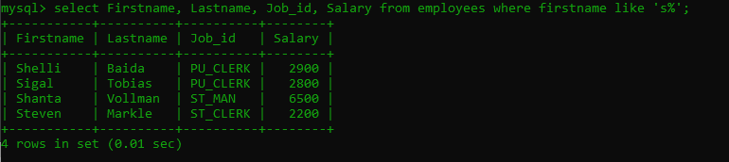

2. Write a query to select employee with the highest salary (using an inner query)

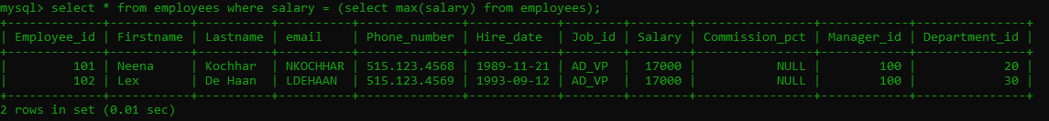

3. Select employee with the second highest salary

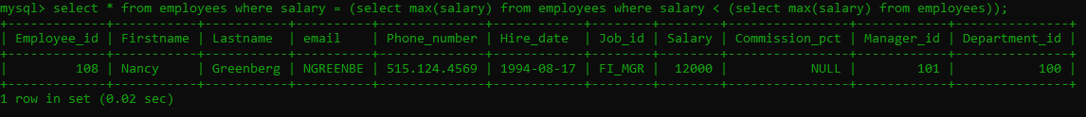

4. Write a query to select employees and their corresponding managers and their salaries

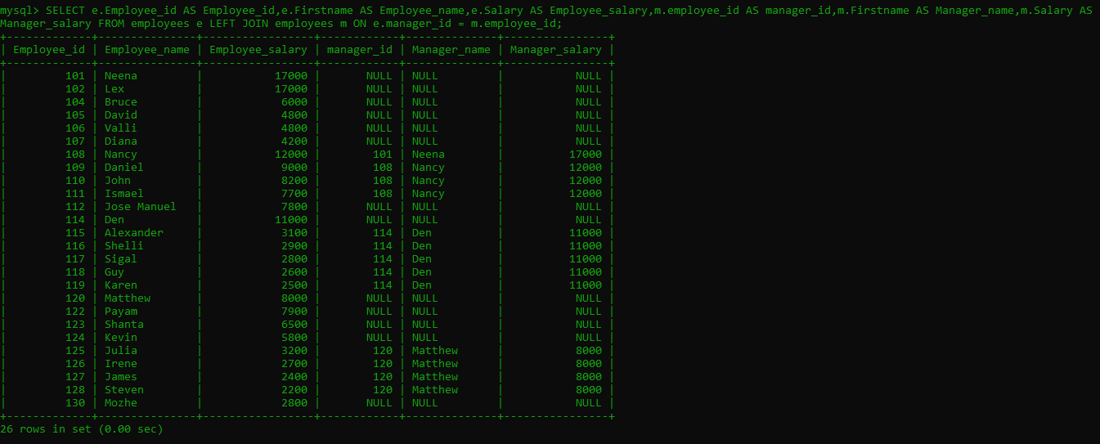

5. Write a query to select employees and their corresponding managers and their salaries (SELF Join)



6. Create a view for the above query

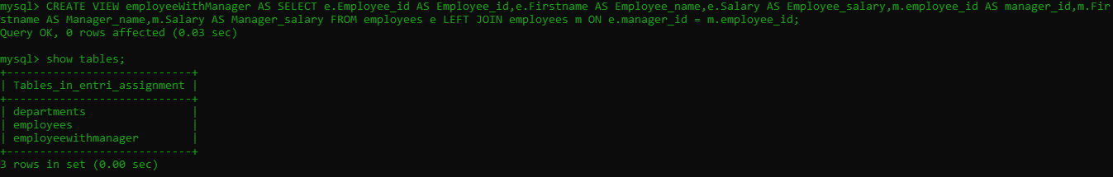

7. Write a query to show the count of employees under each manager in descending order (from view)

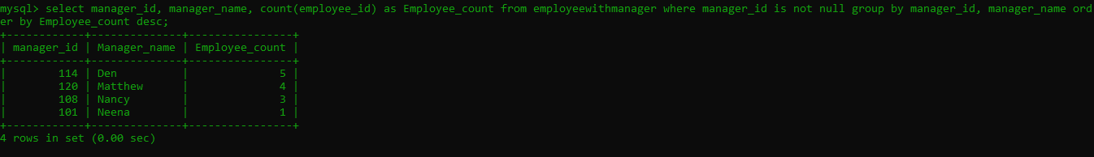

8. Find the count of employees in each department

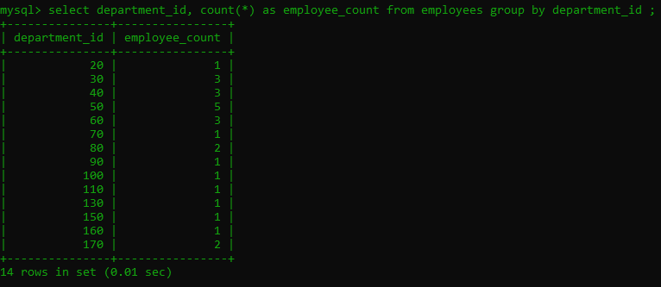

9. Get the count of employees hired year wise

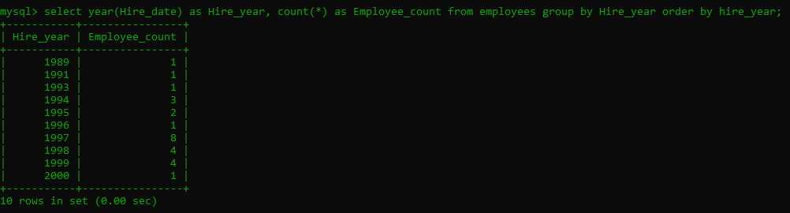

10 . create a stored procedure to get the “ Get the count of employees hired in the input year”(IN year , OUT count)

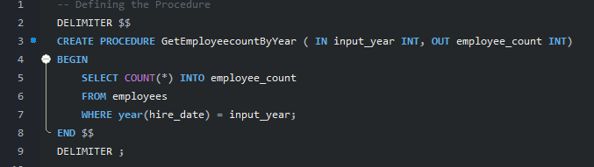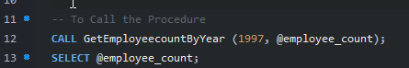

Output:-

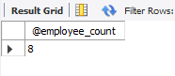

11.Select the employees whose first_name contains “an”

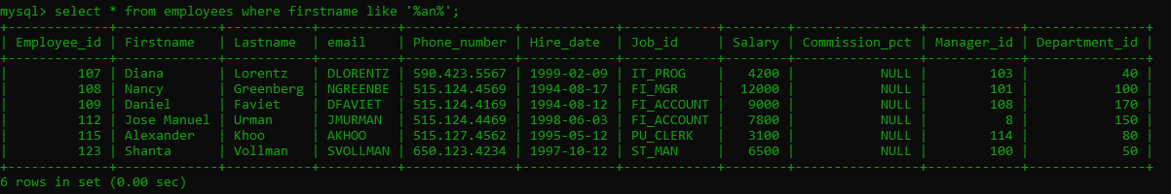

12. Select employee first name and the corresponding phone number in the format (_ _ _)-(_ _ _)-(_ _ _ _)

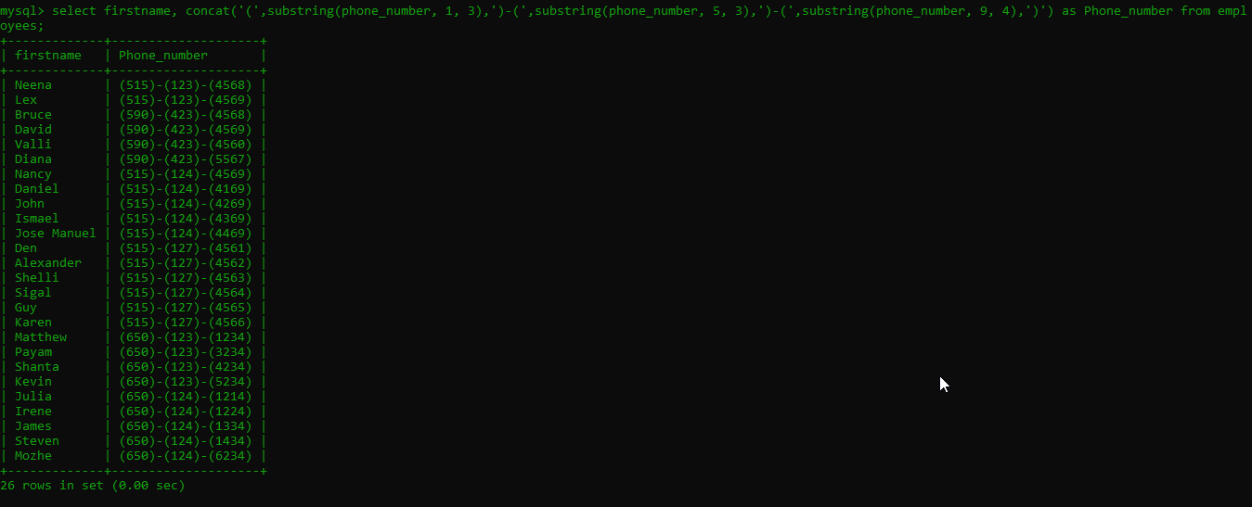

13. Find the employees who joined in August, 1994.

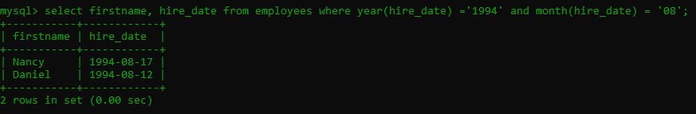

14. Find the maximum salary from each department.

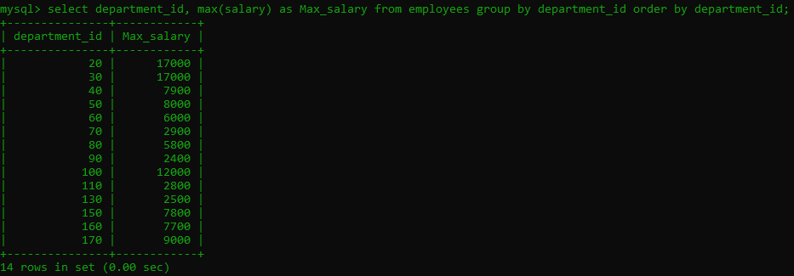

15.Write a SQL query to display the 5 least earning employees

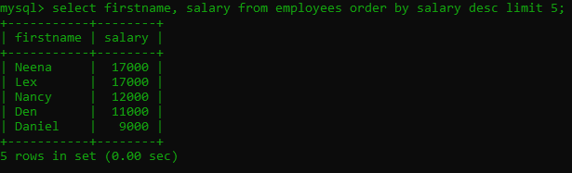

16. Find the employees hired in the 80s

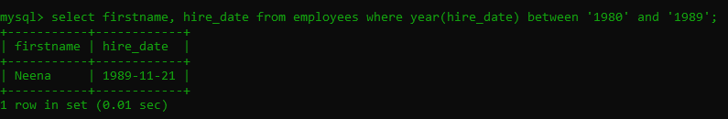

17. Find the employees who joined the company after 15th of the month

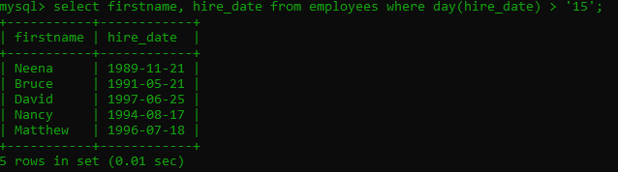

##### By Ismailichu